**LUDWIG VAN BEETHOVEN**

[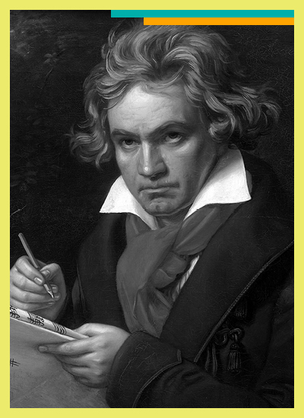](https://www.mydso.com/dso-kids/learn-and-listen/composers/ludwig-van-beethoven#dso-kids-beethoven)

**DATES**

Born December 16, 1770 in Bonn, Germany   
Died March 26, 1827 in Vienna, Austria

**NATIONALITY**

German

**STYLE/PERIOD**

Classical 1750-1820

**FAMOUS WORKS**

Symphonies 1 through 9, Moonlight Sonata, Fur Elise, Fidelio, and Missa Solemnis

**BIO**

Beethoven grew up in Bonn, Germany in a very unhappy home. He was forced to practice the [**piano**](https://www.mydso.com/dso-kids/learn-and-listen/instruments/piano) by his father, an abusive alcoholic who would punish him mercilessly when he made mistakes. By the time he was twelve, he was earning a living for his family by playing [**organ**](https://www.mydso.com/dso-kids/learn-and-listen/instruments/organ) and composing. He was eventually known as the greatest [**pianist**](https://www.mydso.com/dso-kids/learn-and-listen/instruments/piano) of his time. One of Beethoven's favorite foods was macaroni and cheese. He also loved strong coffee - exactly 60 coffee beans to one cup.

Beethoven never married even though he proposed to plenty of women who rejected him (he wasn't very attractive and he had a rather nasty temper). Yet in spite of his unpleasant personality, Beethoven is best defined by his music.

His first two symphonies are very much in the same style and form as those of composers that came before him, most notably [**Franz Joseph Haydn**](https://www.mydso.com/dso-kids/learn-and-listen/composers/joseph-haydn), his teacher. But Beethoven's writing--as seen in his third symphony--had developed beyond that of his teacher. Named *Eroica*, his Third Symphony was so different from the ones that had come before that it changed music forever. Its originality and innovation even inspired others to change the way that they composed. It was originally dedicated to Napoleon Bonaparte. But when Beethoven heard that Napoleon had proclaimed himself Emperor, he went into a rage and destroyed the title page.

Although Beethoven gradually lost his hearing, he continued composing.  He composed many of the most famous musical works of all time, such as his Ninth Symphony, after he had become totally deaf.

**Think about the following questions…**

1. So how did Beethoven compose so many masterpieces while completely deaf?
2. How did Beethoven lose his hearing?
3. Have you ever heard any music that was written by Beethoven?

**How We Hear**

We mostly hear through air conduction, but we hear through elements of bone conduction too! Ever listen to your voice on a recording and wonder why it sounds so different? It’s because we’re used to hearing how our voices sound through a combination of air and bone conduction. Ever plug your ears and hum, and wonder how you can still hear the tune? Yup - that’s bone conduction too! Through our bones is just another path which sound travels.

**The Discovery Of Bone Conduction**

The “phenomenon” of bone conduction is generally credited as being discovered in the 1500s, though some say it can be traced back to around 2AD. A physician, mathematician, philosopher and all-around brilliant fellow by the name of Girolamo Cardano noticed that it was possible to [hear through a rod or spear](http://www.medscape.com/medline/abstract/21389699) when placed between the teeth. He detailed his findings in his controversial publication *De Subtilitate,*but the information hadn’t really been applied to anything, let alone to help the deaf or hearing-impaired, until later.

**The First Hearing Aids**

Fast-forward several hundred years, when Cardano’s controversial findings weren't so controversial, a [number of devices](http://beckerexhibits.wustl.edu/did/timeline/) were fashioned throughout Europe that tapped into this bone conduction phenomenon as a way to improve hearing. It’s been theorized that Beethoven had created his [own version of a rod](http://time.com/4152023/beethoven-birthday/) which, with one end between his teeth and the other against his piano, allowed him to faintly hear the notes that he composed.

Activity-Cut a piece of yarn or string to a 3-foot length. Get two metal coat hangers. Tie gentle knots at the end of the yarn and tie the ends around the first knuckle of both pointer fingers. Hang both metal hangers from the middle of the yarn. Put your pointer fingers gently into both ears (with the yarn attached) and have someone move the metal hangers so they bump and clang together. Can you hear the sound? Your ears are plugged but you can still “hear” the hangers vibrating.

*Now you understand question #1, how you can “hear” vibrations…bone conduction!

**Hearing Loss**

Over the last few centuries, medical experts have tried to find out what it was that caused Beethoven’s hearing loss. Some suggested [Paget’s disease](https://journals.sagepub.com/doi/abs/10.1177/0967772015575883?journalCode=jmba), based on his autopsy report. Another possible cause was otosclerosis, marked by unusual bone growth in the ear. But no condition was able to perfectly explain all of Beethoven’s reported symptoms.

Could Beethoven’s hearing loss also be caused by lead poisoning? It’s not an entirely unusual suggestion, because in 2005 an analysis of Beethoven’s hair and skull samples showed that he did indeed have [high levels of lead](https://www.npr.org/templates/story/story.php?storyId=5041495)in his body. At the time, researchers speculated that this could be linked to a lead gauntlet he regularly drank from, or to years of drinking cheap wine. In Beethoven’s time, lead was added to some wines to improve the flavor, and Beethoven went through phases of heavy drinking.

*Now you have an idea of how Beethoven may have lost his hearing (question #2).

*Question #3-Have you ever heard any music that was written by Beethoven?

Of course you have! Listen to Symphony #5, sound familiar? Symphony #9 is well-known. Make sure you listen to Fur Elise. Are any of these masterpieces a ringtone on your telephone?

**Suggested websites:**

DSO kids

Classics For Kids

SFS Kids

Youtube (Look up Beethoven’s 9th Symphony from the movie Sister Act)

**Materials:** Yarn, wire coat hangers

**National Standards:** #6-Listening to, analyzing, and describing music.

#9-Understanding music in relation to history and culture.